Luc and Friends Scum meetings:

Scrum meeting 1: 7 April 12:20-12:26
Erin and Luc work on home pages and dashboards.
Yami is going to finish apis for the database tables
Need to start working on proper backend stuff, google auth, rooting to other pages.

For now: main goal- resident home page
Adding wards- Fakir
Getting user locations - Chris
Google 0 auth login - Luc (user registration)
Notifications/pulling reports- Erin
Contact information editing (user icon management) – Yami
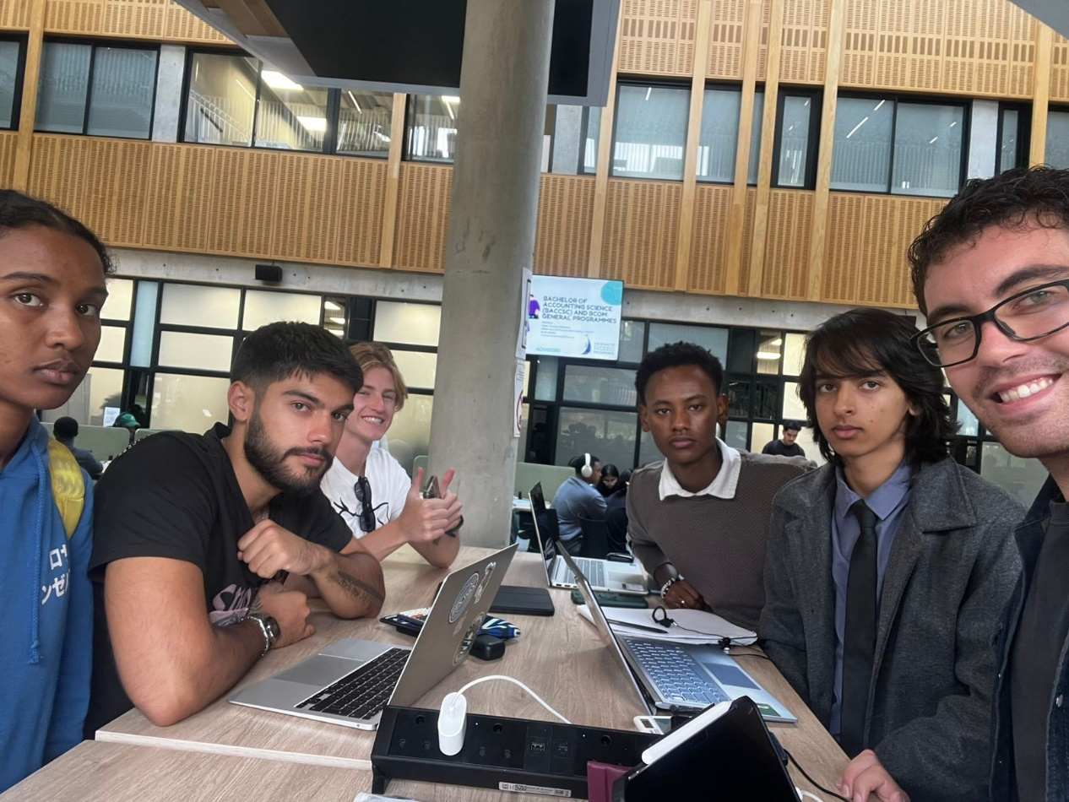

Scrum Meeting 2: 8 April 08:45- 08:52

Fakir has done all the models and index pages for logic associations.
Yami is working on endpoints, specifically workers.
Erin is still on municipal workers page.
Chris is going to help Yami.
Luc will carry on with the login/google auth.

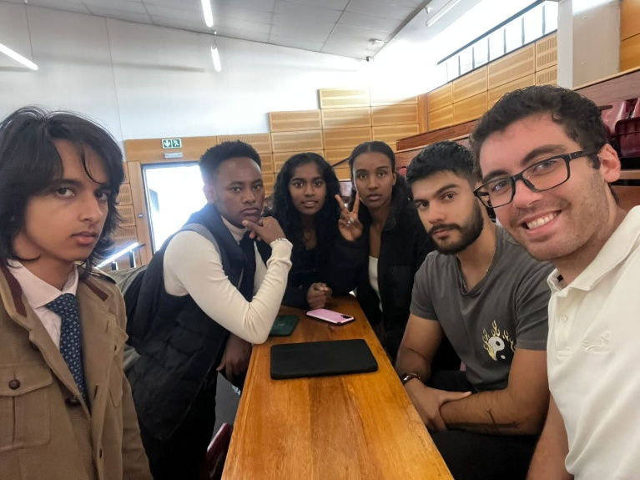

Meeting 3: 10 April 19:47-19:54

Luc is done with the login auth for residents, will work on workers tomorrow.
Chris will do admin page.
Yami route files are pretty much done, will be done tomorrow.
Fakir will carry on with wards.
Yami explained some of the database models and how they connect to Fakirs work. Luc talked about the Google auth and how the password part in the login is useless if we’re not using passwords but rather Google Auth to login/sign up.

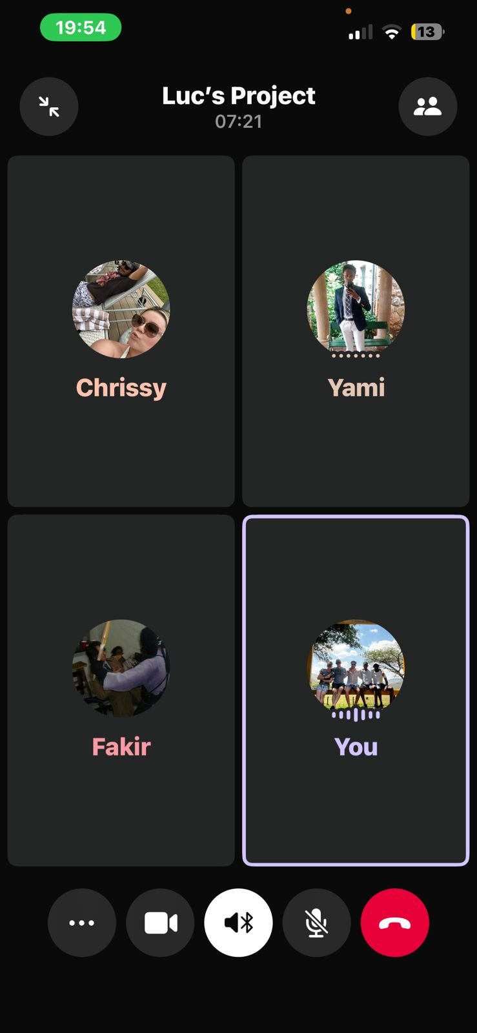

Meeting 4 11 April 09:00-09:03

Luc will finish municipal workers logon for Google auth.
Yami will finish up endpoints
Erin will get workers page done and start with notifications functionality.
Chris will finish admin page so we can add an admin user and have it redirect there from the login page.
Fakir will build all Jest cases for testing of his and Yami’s backend code.

